Wind-Controlled, Heavy-Water (Deuterium) Powered
Aardvark Cooling System

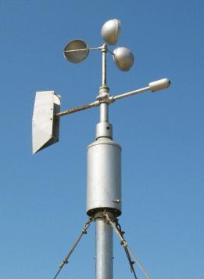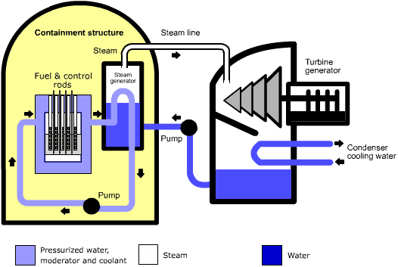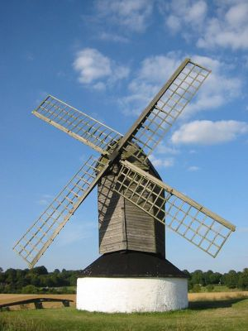
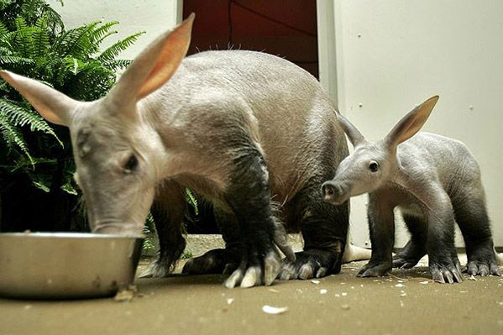

Submitted in Partial Fulfillment of the
Requirements for IENG 475

Dr. Dean H. Jensen
Instructor

By
Lab Team 10:
Emma Student
Etta Notherstudent
Andy Isastudent, II

March 3, 2009

Contents Page

Introduction 1
Problem Statement

Product Description 3
Product Characteristics
Product Operation
Product Storage and Maintenance

Manufacturing Process Summary 6
Capacity Requirements (Personnel and Equipment)
Process Description (Operations Process Chart)
Estimated Time and Costs

Conclusion & Recommendations 8
Acknowledgements & References

Appendices 9
Appendix A: Indented Bill of Materials
Appendix B: Work Instructions
Appendix C: Tooling and Fixtures Listing
Appendix D: Routing Sheets
Appendix E: Engineering Notebook Copies
Student 1
Student 2
Student 3
Student 4
Student 5
Appendix F: Basic Playing Instructions (Optional – Bonus)

INTRODUCTION

Type your introduction here. Use appropriate sentence and paragraph structures, and check for correct spelling. Watch capitalization – especially with proper nouns (such as Mastercam® and SolidWorks®). The introduction should be about one page long.

Problem Statement

Type your problem statement here. Follow the problem statement with a short description of the necessary assumptions and constraints.

PRODUCT DESCRIPTION

Product Characteristics

Insert an overview of your product’s characteristics here. You should include things like overall dimensions, weight, major materials, finish options, etc. If there are any disclaimers (i.e. intended user limitations), insert them here, too.

Product Operation

Describe the operation of your product in this area. For example: (1) how do you prepare it for use; (2) how do users manipulate it to perform its’ intended function; and (3) how do you close it back up when you are done using it?

Product Storage and Maintenance

Place a description of how people are supposed to store it for a long period of time (things like heat, humidity, and sunlight might degrade the product). Also explain how the user would take care of things like routine cleaning and how to obtain or perform anticipated service.

MANUFACTURING PROCESS SUMMARY

Capacity Requirements

Briefly discuss the manufacturing capacities needed to produce this product. This would include such things as: (1) anticipated personnel and their skill sets; (2) planned equipment and its’ minimum capabilities – like horsepower, required spindle speed ranges, machining volume (part and tooling space); and (3) facility requirements – like required floor space (ft²), ceiling height, and electric or pneumatic power that should be available.

Process Description

This section is where you describe the overall manufacturing process. You do not need to go into detail for each operator (after all, you have the work instructions listed in the Appendices), but you should let the reader know what and/or which operations are proceeding at the same time, and what things are happening sequentially. A graphic description, like an Operations Process Chart, would be particularly valuable here.

Estimated Time and Costs

The topic of this section is a concise estimate of the anticipated production time needed and the material and direct labor costs on a per unit basis. It might not be a bad idea to estimate the overhead and other costs needed to fix a before-profit selling price, too.

CONCLUSION & RECOMMENDATIONS

This final section of your project documentation should assess the quality of your project as described and processed herein. In addition, the instructor would also like your collective, team assessment of the laboratory exercises for this course. Finally, this is also a good place to suggest changes to the laboratory facility that would enhance the educational experience for a project of this type.

Acknowledgements

Mastercam® is a trademark of CNC Software, Inc.
Educational Division
5717 Wollochet Dr. NW
Gig Harbor WA, 98335 USA

SolidWorks® is a trademark of Dassault Systèmes SolidWorks Corporation.
300 Baker Avenue
Concord, MA 01742

Cover Photo Credits

Aardvarks – Awwww; (May 31, 2006) Scotto Bear, North Beach, MD. Licensed under:
Creative Commons Attribution ShareAlike 2.0

Anemometer – Anemometer; (Mar. 3, 2009) at:
http://www.smg.gov.mo/dm/equip/e_ws.htm

Reactor – Pressurised Water Reactor; (Mar. 3, 2009) at:
http://www.uraniumsa.org/uses/electricity.htm

Windmill – How To Build a Windmill; (Mar. 3, 2009) at: http://monsterguide.net/how-to-build-a-windmill

APPENDIX A: Indented Bill of Materials

Insert this document after this cover page, then remove this line of text.

APPENDIX B: Work Instructions

Insert this document after this cover page, then remove these lines of text. Or replace this text with your own instructions directly on this page, if you desire.
APPENDIX C: Tooling and Fixtures Listing

Insert this document after this cover page, then remove these lines of text. Or replace this text with your own listings directly on this page, if you desire. These should be listed in table form, with a new table for each machine. If a table runs over a page break, start the table on a new page.

APPENDIX D: Routing Sheets

Insert these documents after this cover page, then remove these lines of text. There should be one for each major component, and each component should start on a new page.

APPENDIX E: Engineering Notebook Copies

Insert photo copies of only the relevant engineering notebook pages from each team member, then remove these lines of instruction. This section will include things like dates of team meetings / labs, personnel present, activities undertaken, decisions made, and data collected. It should also contain things like next planned actions. Make sure that it is clear whose notebook pages are provided (there should be more than one per team-member, and the content should be somewhat redundant if all participated).

APPENDIX F: Cribbage Instructions

This is a bonus section, and not strictly necessary. Do not copy another author’s work (plagiarism), but do succinctly describe the basics of how to play the game for your product set design. If you do not include instructions, delete this page (and remove the entry on your Table of Contents, too). Otherwise, replace these lines of text with your instructions.

