Binomial Nomograph for Single Sample Acceptance Sampling

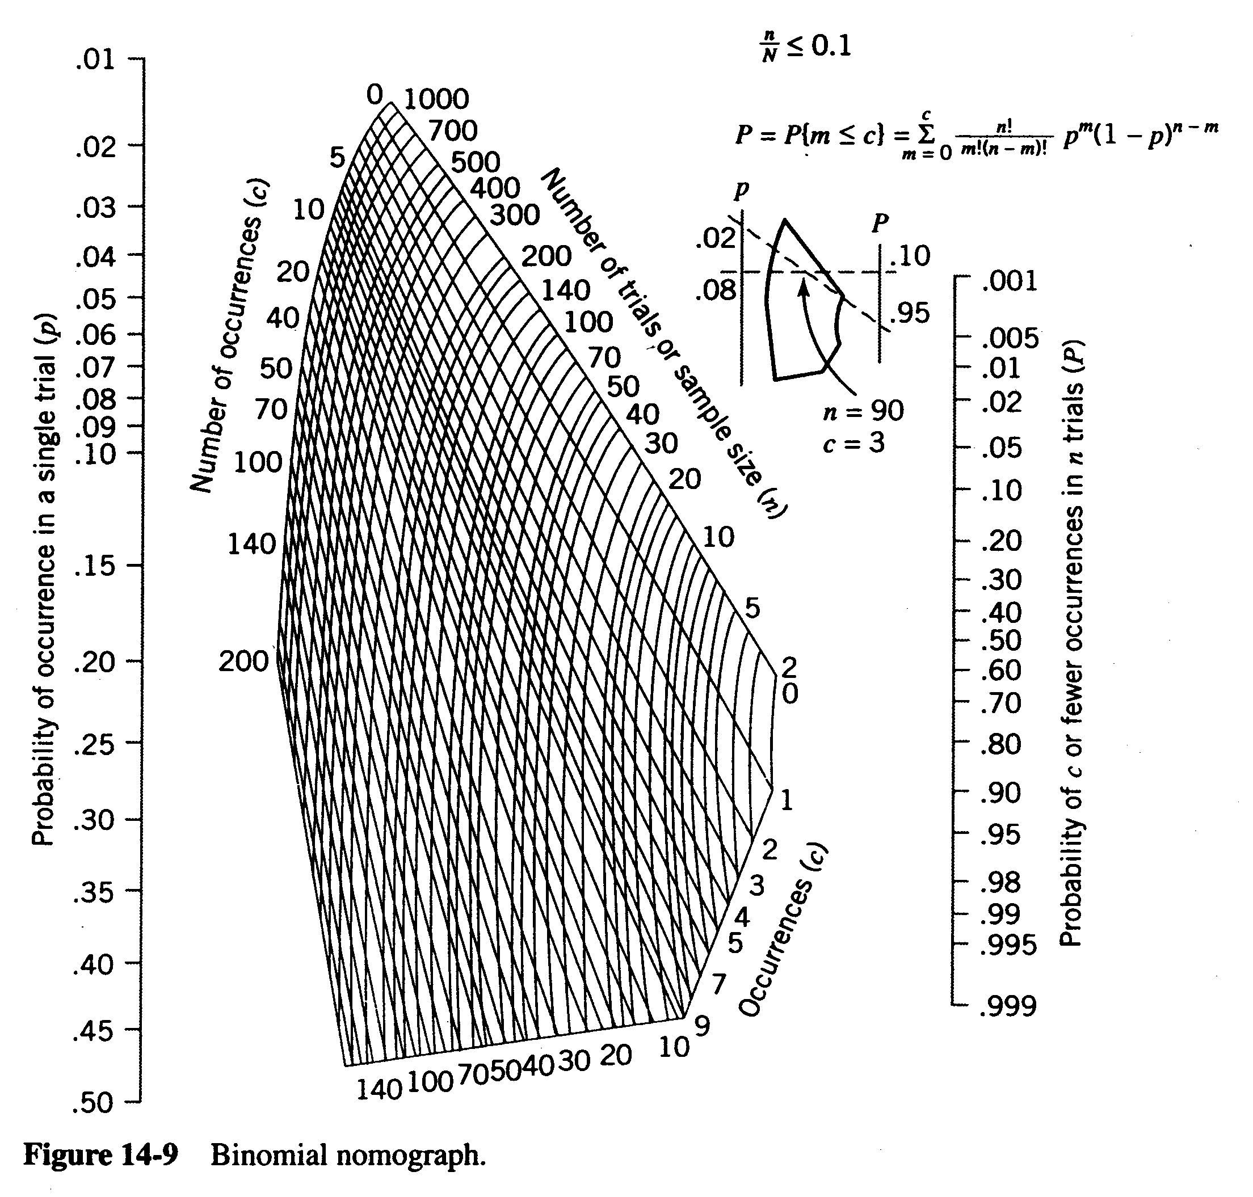

n = ______

c = ______

